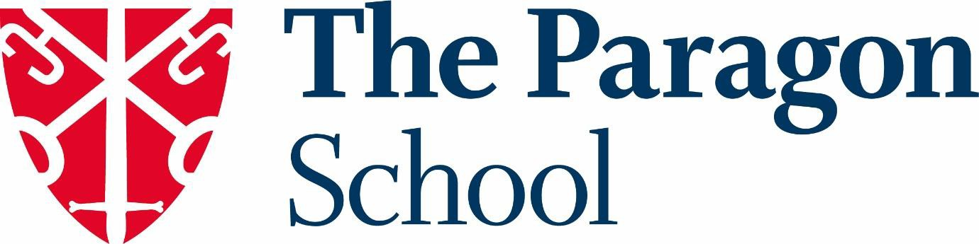

The Paragon School is part of the Prior Park Educational Trust.

Mission Statement:
To steward a thriving family of communities with love for the young people they serve at their heart. Communities which cultivate creativity, foster integrity and transform lives.

The mission statement is underpinned by our values:
Curiosity Generosity Courage

The Paragon is an independent, co-educational day school based in a beautiful Georgian house a mile from the centre of Bath. It has eight acres of gardens and woodland and enjoys access to superb science, sporting, creative and academic facilities at the senior school, Prior Park College.

The Paragon School
Catering for more than 250 children aged three to 11, we offer a broad curriculum taught in small classes by teachers with a real passion for their subject. The school comprises Squirrels Pre-School, our Pre-Prep and Prep School.

Our Values and Vision
The School’s Head, Rosie Allen, describes the school as:

"The Paragon journey is one of limitless discovery. Each child enjoys a fully immersive educational experience, rooted in our school values whilst exploring and developing their attributes as learners. Adventures are wide and varied, centering on the beauty and joy of childhood alongside preparation for the world beyond."

