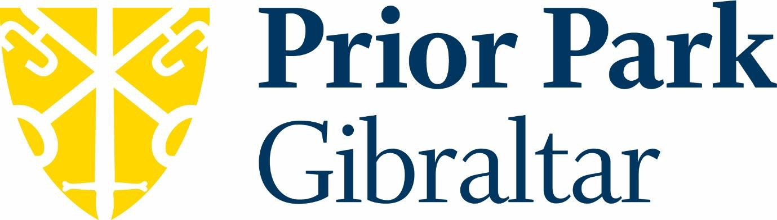

Prior Park Gibraltar is part of the Prior Park Educational Trust.

Mission Statement:
To steward a thriving family of communities with love for the young people they serve at their heart. Communities which cultivate creativity, foster integrity and transform lives.

The mission statement is underpinned by our values: Curiosity
Generosity Courage

Prior Park School is a co-educational, Catholic day school located in the British Overseas Territory of Gibraltar, set high up on the Rock at the edge of the Gibraltar Nature Reserve, with stunning views across the water to Spain and Morocco.

Prior Park Gibraltar
The School roll in September 2023 will be 256, split 48% male / 52% female. This includes 50 Sixth Form students. We have several students who cross the international border between Spain and Gibraltar each day to attend our school, as well as mixture of local Gibraltarians, British expats and families from many other countries who reside in Gibraltar.

Our Values and Vision/Prior Park Gibraltar
The Head of Prior Park School, Mr Peter Watts captures the school’s ethos as:

“A child‘s school life should be an exciting and enjoyable journey towards a realisation of their full potential”.

