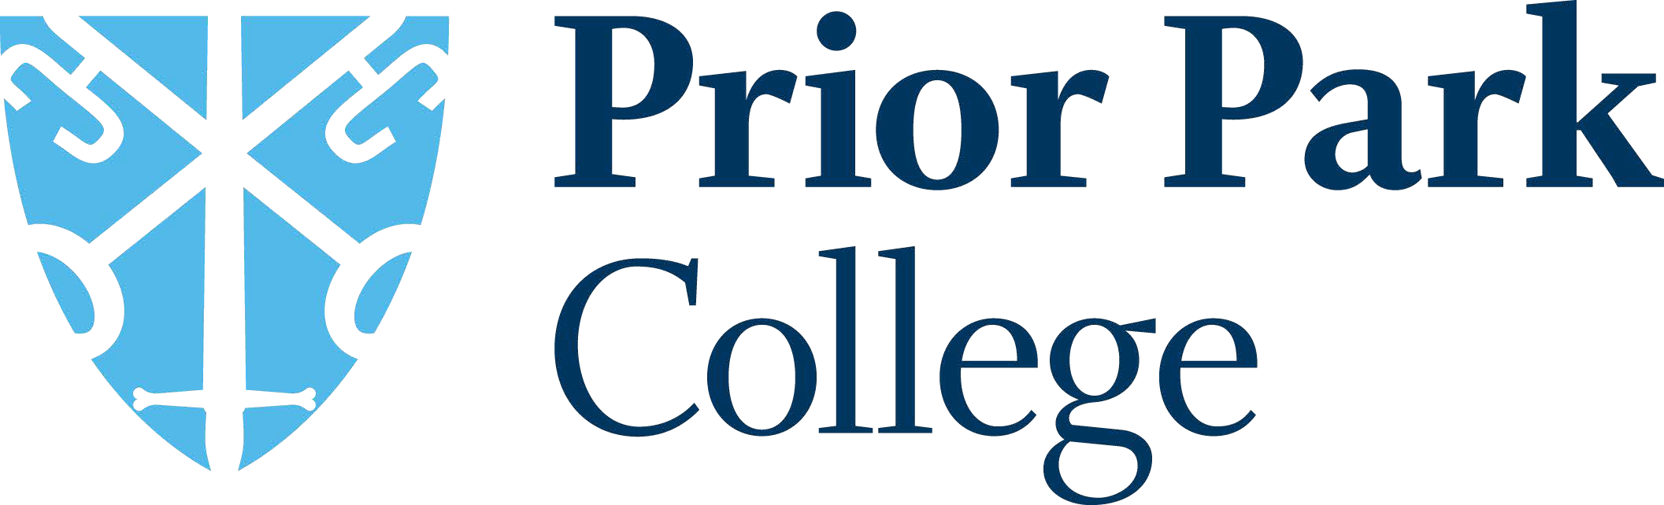

Prior Park College is part of Prior Park Educational Trust.

Mission Statement:

To steward a thriving family of communities with love for the young people they serve at their heart. Communities which cultivate creativity, foster integrity, and transform lives.

The mission statement is underpinned by our values:
Curiosity Generosity Courage

Prior Park College is a co-educational, day and boarding, Catholic senior school set in a breath-taking location, overlooking the UNESCO World Heritage City of Bath.

Prior Park College | An Outstanding, Independent School in Bath
The College roll in September 2023 will be 612 students, split 58% male / 42% female. This includes 213 Sixth Form students. We have up to 154 full, weekly and flexi boarders
from 20+ countries use the two boarding houses as their term-time homes.

Our Values and Vision | Prior Park College
The school's approach is simple:
We value each individual and focus our attention on developing their unique talents to ensure an education of the whole person.

